Commandaria - Exhibition Blueprint
Construct your exhibition & exhibits
Sub-section: | Winemaking
Exhibit number: | 1
Name of the exhibit: | Mapping Commandaria Villages
Type of exhibit: | Tangible or digital
Recommended preparation time: | 30 minutes
Required students: | Groups of 2-4 students
Brief description: | An explanatory map of Commandaria and other vineyards of Cyprus. The map presents the location of vineyards in Cyprus where Commandaria wine is mainly produced and are considered as Commandaria-verified regions.
Materials and/or tools needed: | - Exhibit 1 Resource: Explanatory Map (printed out or digital)  - Descriptive labels (printed or digital)  - Digital device (optional)  - Collage materials (glue, paper, blu tac)  - Space to lay out map or table & plug for electronic device
Dimensions of the exhibit: | The physical dimensions of the map and the labels are proportional according to the size of the map given. For example, if the map is 150 x 100 cm, the labels will be 10 x 5 cm. The digital map is the same.
Step by step construction instructions: | Step 1: Prepare the materials needed according to the number of students. It is suggested to give 1 map to a group of max 4 students. Provide students with collage materials and prepare labels in advance (print or digital).  Step 2: Pass the maps and show them the basic features of the map.  Step 3: Let them explore the map for 2-3 minutes.  Step 4: Students start collaging the labels in the right place.  PS. The map can be enlarged as much as needed, and presented both digitally and/or in printed format  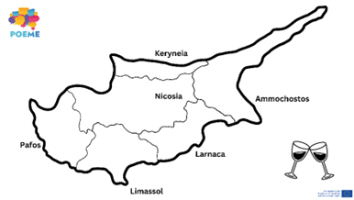  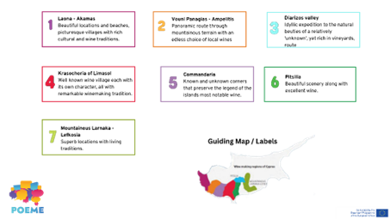

Sub-section: | Winemaking
Exhibit number: | 2
Name of the exhibit: | Process Book Station
Type of exhibit: | Digital
Recommended preparation time: | 30 minutes
Required students: | Groups of 2-4 students
Brief description: | It is a book that will outline the winemaking process. It will outline the two types of indigenous Cyprus grapes and at least five of the main stages of Commandaria production.
Materials and/or tools needed: | Students will use a digital device (phone/tablet/laptop) to research the main steps and find the best images for every step. Create a digital album of images using book creation software. Recommendation: Book Creator or Canva. Students can also use the POEME Commandaria e-book and/or worksheet
Dimensions of the exhibit: | Digital format – can be viewed digitally or downloaded as an e-pub file. They can use any medium they already engage with.
Step by step construction instructions: | Step 1: Start the research process  Step 2: Collection of photographs of the process (reference images)  Step 3: Use Book Creator or Canva to create a Process Book with audiovisual material  Step 4: At the end, students will give feedback and comment on their albums

Sub-section: | Winemaking
Exhibit number: | 3
Name of the exhibit: | Mixed Up!
Type of exhibit: | Tangible
Recommended preparation time: | 30-40 minutes
Required students: | Individual activity, students can come together as a group in the end
Brief description: | This is a messy play activity where students can engage in the process they explore in the previous exhibit. They will be given fruits and juices to crush using their hands and tools to make their own “wines”. The activity is meant to be experiential and help them better engage with the process of mixing materials and creating something from scratch.
Materials and/or tools needed: | - Variety of seasonal fruits & juices  - Kitchen tools (measuring cup, spoons, peeler, etc.)  - Food smashing objects (e.g., food smasher, blender, juice squeezer etc.)  - Aprons  - A3 paper  - Table
Dimensions of the exhibit: | Messy play – Experiential activity
Step by step construction instructions: | Step 1: Each student will select 2-3 fruits and one juice flavor.  Step 2: Students will try to engage in the creation process by mixing the fruits and juices together, picking their own analogies to create “wine” from scratch. Students will need to keep a record or “recipe” during their process.  Step 3: Students will present their product; explain how they made it and can try out each other’s creations to compare.  Step 4: Using the A3 paper, students will collectively create a wine-book, with a collection of all their recipes.

Sub-section: | Winemaking
Exhibit number: | 4
Name of the exhibit: | Becoming “Wine” Connoisseurs
Type of exhibit: | Tangible and/or Digital
Recommended preparation time: | 15-20 minutes
Required students: | Individual activity (groups of 1)
Brief description: | The rating activity will be an introduction to wine experts and wine tasters. Students will become familiar with these processes by practicing their tasting skills. Juices will be used instead of natural wine for this activity, and the process will be the same. Students will rate the “wine” according to its look, smell, and taste and then add an overall conclusion/rating.
Materials and/or tools needed: | - Exhibit 4 Resource: Wine Expert Rating Activity (or something similar)  - Pens/markers  - 4 types of juices  - Glasses/cups  - Table
Dimensions of the exhibit: | The activity does not have a dimension/form/format. The rating activity can be executed digitally using electronic devices or physically by printing out A4 copies of the rating activity table. Tasting can only be done physically.
Step by step construction instructions: | Step 1: Introduction to Wine experts and the variety of jobs in the wine factory  Step 2: Explanation of the tasting and rating handout.  Step 3: Tasting begins. Students will be asked to express their opinion regularly during this activity. They will note down their observations individually or in small groups  *Handout resource in pdf format (physical or digital).  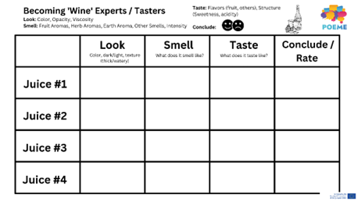

Sub-section: | Medieval Ages
Exhibit number: | 5
Name of the exhibit: | A Historical Timeline
Type of exhibit: | Tangible and/or Digital
Recommended preparation time: | 15 minutes
Required students: | 5-6 students per group
Brief description: | This activity aims to explore the medieval Ages and the history of Commandaria. Students are asked to read a text on Commandaria, note down the most important events related to its history and then place them chronologically on the timeline provided.
Materials and/or tools needed: | - Exhibit 5 Resource: Timeline Text (or something similar)  - Exhibit 5 Resource: Commandaria History timeline (printed pdf or digital) (or something similar)  - Pens & Papers or electronic device  - POEME Commandaria E-worksheet and/or E-book (optional)
Dimensions of the exhibit: | Life-size historical timeline (accordingly to the available floor/wall space)
Step by step construction instructions: | Step 1: Share the written text on Commandaria’s history with students  Step 2: Students read the text and highlight the most important events throughout its history  Step 3: Students use the timeline to place the events chronologically.  Step 4: Hold an open discussion in the case where students have very different answers and ask to explain their choices.  *Resource given in pdf format (physically or digitally)  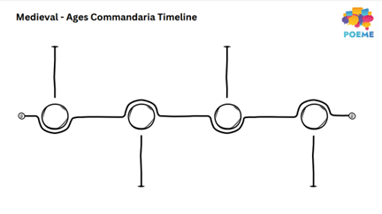

Sub-section: | Medieval Ages
Exhibit number: | 6
Name of the exhibit: | Battle of the Wines – Tell your own story
Type of exhibit: | Intangible and/or digital
Recommended preparation time: | 30-45 minutes
Required students: | 2-4 students per group
Brief description: | Students are asked to take the roles of characters during the Medieval Ages and create dialogues in an imaginative story to re-enact the Battle of the Wines competition organized by King Philip II. Students are expected to improvise in an acting activity and try to use the vocabulary learned so far from previous activities.
Materials and/or tools needed: | - Exhibit 6 Resource: Storytelling guidelines (or something similar)  - Commandaria wine bottle  - Other wine bottles (preferably from different countries)  - Chair (for King)  - Medieval Ages related props (optional)  - Medieval Ages costumes (optional)  - Camera for recording/projector (optional)
Dimensions of the exhibit: | Role Play Activity – acting performance. The activity can be performed once physically and then recorded to be displayed digitally (using a projector/screen) in a loop for the remaining duration of the exhibition.
Step by step construction instructions: | Step 1: Read the Exhibit 6 Resource and divide the roles to students (or something similar)  Step 2: Students brainstorm and create a fictional dialogue with their characters related to the period and the Battle of the Wines  Step 3: Students perform their work to everyone  Step 4 (Optional): Students can record their performance once and then display it using a projector in a continuous loop  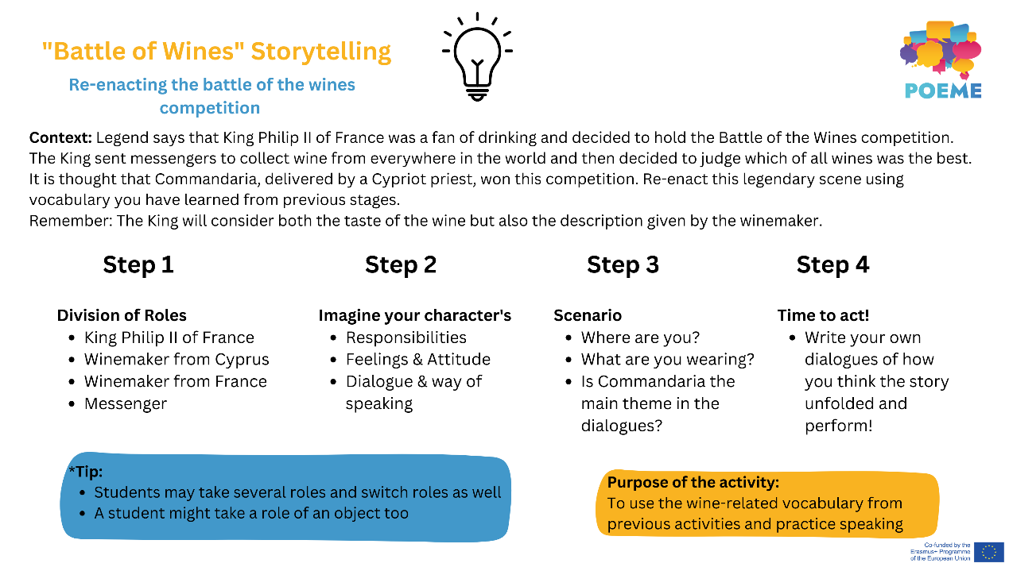

Sub-section: | Tradition
Exhibit number: | 7
Name of the exhibit: | Paint your Way
Type of exhibit: | Tangible
Recommended preparation time: | 20 minutes
Required students: | Individual activity or in pairs
Brief description: | This activity seeks to use Commandaria as an artistic medium to create either representative or non-representative drawings – ideally related to the wine itself. The final result will be exhibited in the space available and students can also add a small description and label of their painting (in the classroom, hall, etc.).
Materials and/or tools needed: | - A3 watercolor paper for each student  - Commandaria wine  - Aprons  - Paint brushes/painting tools  - Pins and/or Blu Tac (for display)  - Grape leaves & branches (optional)  - Tables/small stations
Dimensions of the exhibit: | Activity can take place in a classroom, art studio or open space where students have the space to paint and experiment with the artistic medium. Each student can have their own station (table, booth, etc.) to work on individually
Step by step construction instructions: | Step 1: Students will be introduced to using Commandaria as a medium to paint.  Step 2: Using Commandaria wine as an ‘ink’ medium and/or materials which make up Commandaria wine, students will create their own artistic creations  Step 3: Ask students to write a small description of their piece of art and add a label with the title of the painting  Step 4: Compile a collection of the paintings for display in the classroom or school rooms.

Sub-section: | Tradition
Exhibit number: | 8
Name of the exhibit: | DIWine – Do-it-yourself-Wine
Type of exhibit: | Tangible or Digital
Recommended preparation time: | 25-30 minutes
Required students: | 2-3 students per group
Brief description: | In this activity, students will learn how to brainstorm about a product’s Unique Selling Point (USP) step by step. They will first brainstorm about the different points provided on the template, and then proceed to create a catchy logo and brand title. They will use their abilities to market and customize their brand idea to try to “sell” it to potential buyers.
Materials and/or tools needed: | - Exhibit 8 Resource: USP Brainstorming (or something similar)  - Re-used or recycled Wine/Commandaria Bottles  - Adhesive/non-adhesive Labels  - Paper  - Pens & colorful markers  - Electronic device (optional – for research and/or printing/designing)  - Tables/small stations
Dimensions of the exhibit: | The activity can be conducted digitally using design software such as Canva to model a brand and complete the brainstorming digitally. If done physically, student groups should have a dedicated space in the room to lay their materials and sketch out their ideas.
Step by step construction instructions: | Step 1: Brainstorm for wine business ideas  Step 2: Complete the USP parameters  Step 3: Design the Logo Label and the bottles  Step 4: Present their product to the rest of the class and try to “sell” it – market it  (Optional) Step 5: Students can vote the group whose design and marketing pitch is believed to have been most effective 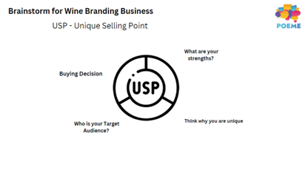

Sub-section: | Tradition
Exhibit number: | 9
Name of the exhibit: | Commandaria – A short film
Type of exhibit: | Digital
Recommended preparation time: | 5-10 minutes
Required students: | All students
Brief description: | In this activity, students will learn how to display a digital video with the equipment available. Using audio devices and monitors to set up the display. They are expected to be well informed about the video as questions may be asked at the end.
Materials and/or tools needed: | - Exhibit 9 Resource: Commandaria Short Film (or something similar)  - Monitor & Speakers  - Screen/Laptop/Projector
Dimensions of the exhibit: | Display of work. Wall or screen size depends on the space available. A TV screen or laptop could be also suitable.
Step by step construction instructions: | Step 1: Set up devices on which to watch the video (e.g., projector, screen, laptop, sound etc.)  Step 2: Watch video & take notes  Step 3: Prepare for questions

