Golden Age of Acropolis – Exhibition Blueprints
Construct your exhibition & exhibits
Sub-section: | The Classical Age
Exhibit number: | No 1
Name of the exhibit: | The Classical Age
Type of exhibit: | Tangible
Preparation time: | 1 - 2 hour
Required students: | 3
Brief description: | A photo gallery about the first sub-section. It will be 4 in total, printed and hung on the wall, accompanied by brief descriptions.
Materials and/or tools needed: | A printer that supports A2 size papers, tape
Dimensions or format or form: | All the pictures should be printed on A2 size paper (420x594 mm), horizontally.  The brief descriptive labels should be in “Arial” font, size 16.
Step by step construction instructions: | - Download the following pictures that represent the Classical Era, Perikleus, and the Acropoli  (a. Wallpaper Acropolis, Athens, Greece, sky, clouds, 5K, Travel #23357, b. Pericles | GONZOfoto | Flickr, c. Αρχείο:Pericles Pio-Clementino Inv269.jpg - Βικιπαίδεια, d. https://www.lookandlearn.com/history-images/A002051/The-Golden-Age-Athens-Crowning-Glory?img=4&search=Athens&cat=look-and-learn-collections&bool=phrase, )  - Print them and tape them, one next to the other on a wall  - Print the labels and place them underneath each picture.  It should look like the following: 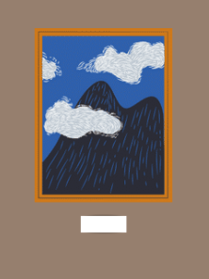

Sub-section: | The Classical Age
Exhibit number: | No 2
Name of the exhibit: | Experience the Acropolis Hill
Type of exhibit: | Digital
Preparation time: | 1 week (Depending on the delivery duration)
Required students: | 2
Brief description: | A 360⁰ video showing around Acropolis. Participants will scan a QR code with their phones and experience the video. VR goggles will be also provided.
Materials and/or tools needed: | Printer for the QR code, paper, a plexiglass case, 3 cardboard VR goggles, and this video (360° Explore the ancient Acropolis in Athens - BBC).
Dimensions or format or form: | The QR code dimensions should be 20x20 cm
Step by step construction instructions: | - Step: Order online these cardboard VR goggles: https://arvr.google.com/cardboard/get-cardboard/  - Print the QR code of the video  - Place it inside the plexiglass case  - Place the QR code with the 3 VR goggles on a small table or tool.  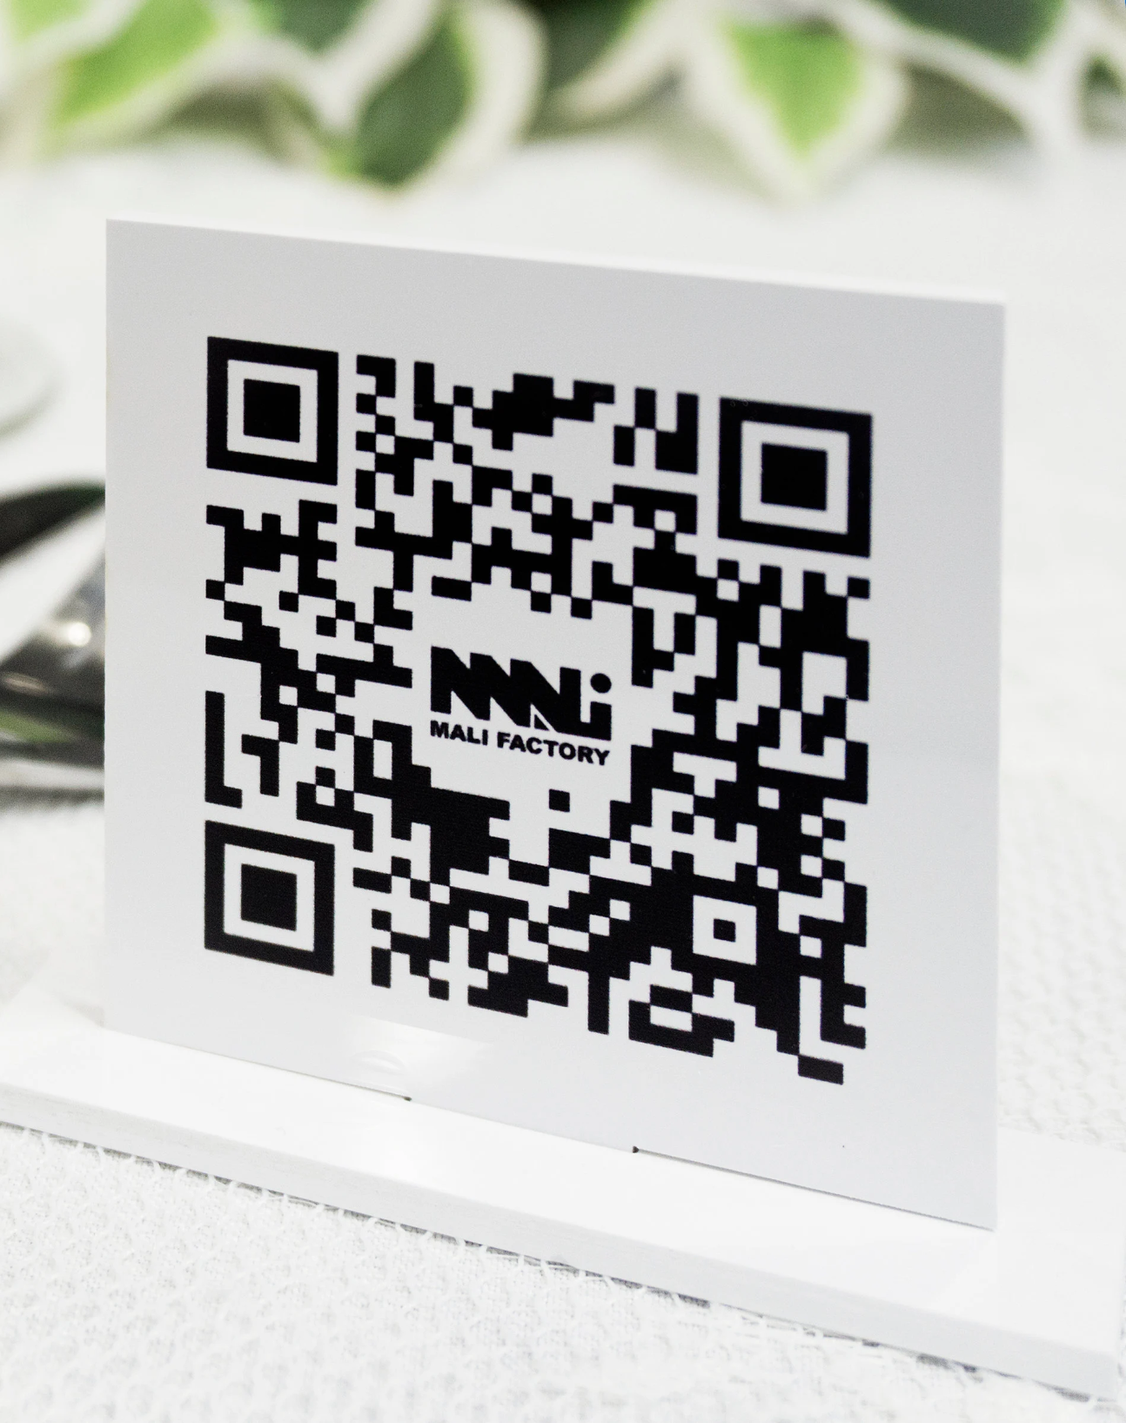

Sub-section: | Acropolis and its Monuments
Exhibit number: | No 3
Name of the exhibit: | The monuments of Acropolis
Type of exhibit: | Tangible and Digital
Preparation time: | 3 hours
Required students: | 5
Brief description: | A photo gallery with pictures and information from the Acropolis Museum Website
Materials and/or tools needed: | A printer that supports A0 size papers, papers, a large piece of string for hanging, black paper clips (at least 8), ceiling hoops with tape (at least 8).
Dimensions or format or form: | All the pictures should be printed on A0 size paper (841 x 1189 mm), vertically.
Step by step construction instructions: | - Step: Design each paper with a picture on the side, descriptive text, and a QR code that is linked to the museum website. The information will be mined by: The Temple of Athena Nike | Acropolis Museum | Official website , The Propylaia | Acropolis Museum | Official website , The Erechtheion | Acropolis Museum | Official website, Athena Promachos - Wikipedia ,  - Calculate the distance between the top of the photo and the ceiling. The bottom of the photograph should be 1,5m from the ground.  - Attach the ceiling hooks  - Cut the string and attach 2 on each piece of paper  - Hang them  Here are some example pictures to help you.  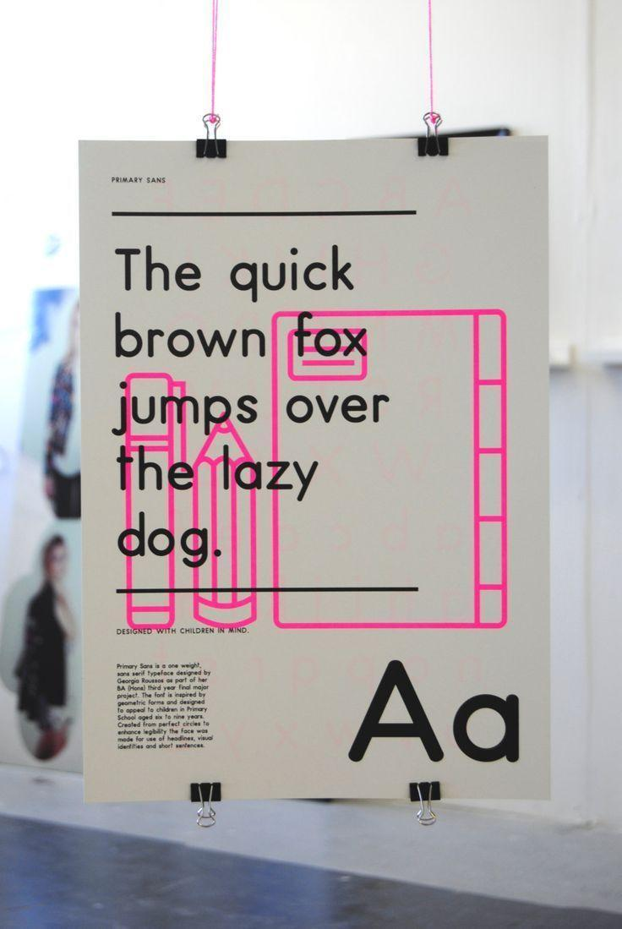  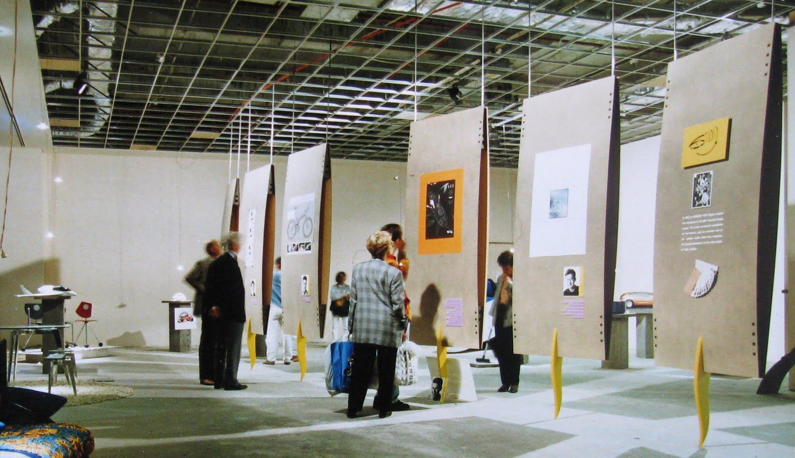

Sub-section: | Acropolis and its Monuments
Exhibit number: | No 4
Name of the exhibit: | The Parthenon
Type of exhibit: | Digital
Preparation time: | 3 hours
Required students: | 3
Brief description: | A short video about the Parthenon of the Acropolis
Materials and/or tools needed: | A Smart TV, tv wall base, the Parthenon video (The Parthenon - 3D reconstruction), floor pillows and pouffe cushions (6 -8).
Dimensions or format or form: | The TV device should be 75".
Step by step construction instructions: | - Install the TV on the wall  - Place the floor pillows/pouffe around the TV  - Download the Video and have it play in a loop  A small sketch for inspiration: 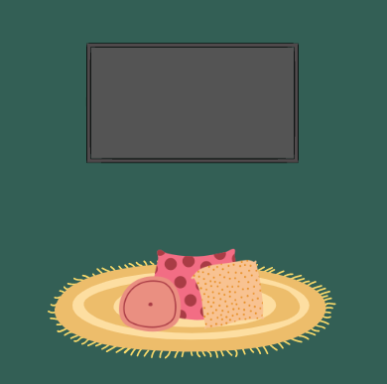
Sub-section: | Acropolis Remembrance
Exhibit number: | No 5
Name of the exhibit: | Acropolis Virtual Museum
Type of exhibit: | Digital
Preparation time: | 1 hour to 3 days
Required students: | 4
Brief description: | Experience the Acropolis hill with the help of the Acropolis Virtual Tour website
Materials and/or tools needed: | A projector, a laptop, the website of Acropolis Virtual Tour , a small table or stool, white paint (optional)
Dimensions or format or form:
Step by step construction instructions: | - Make sure the room you chose is light-proof  - If the walls are white, move to the next step. If not, paint them white color  - Place the projector and the laptop on the small table or stool  - Connect them together and display the website in the room  The room should look like this, with the projection being the Acropolis  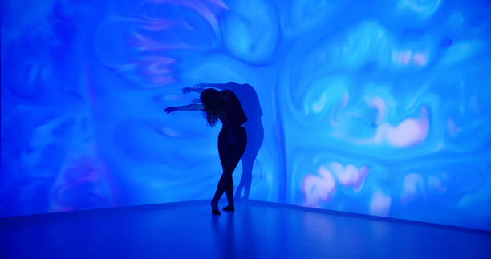

Sub-section: | Acropolis Remembrance
Exhibit number: | No 6
Name of the exhibit: | Who Is It?
Type of exhibit: | Tangible
Preparation time: | 2 hours
Required students: | 3
Brief description: | A stack of cards where each card will portray the ancient ruins and the famous people. Each student will have to pick one, without seeing it, and ask yes/no questions in order to find out his/her/their card
Materials and/or tools needed: | A printer, scissors, a small table
Dimensions or format or form: | The playing cards should be 64mm x 89mm in size and in total 20.
Step by step construction instructions: | - Decide on 10 ancient monuments and 10 famous ancient people to create cards for. (ex the Parthenon, The Temple of Nike, Socrates, Pericles etc)  - Cut them and place them -in stack and face down, on a small table.

