The Unique Olympus Exhibition Bluprints
Construct your exhibition & exhibits
Sub-section: | The unique Olympus
Exhibit number: | No 1
Name of the exhibit: | An experience of a lifetime
Type of exhibit: | Digital
Preparation time: | 1 hour total
Required students: | 2 students (in total)
Brief description: | A short video (07:12min) showing the mountain from the foothills to the top. The video will be displayed on a TV screen nonstop during the exhibition.
Materials and/or tools needed: | A smart tv based on the wall or on a stable table (alternatively you can use a projector and a computer).  A You Tube video about Mount Olympus.  There will be a general explanatory label taped on the wall.
Dimensions of the exhibit: | The tv screen should be at least 50’’
Step by step construction instructions: | - Install the TV on the wall or on a base like a table.  - Find the proper video. (Suggestion: Ανάβαση στον Όλυμπο: Οροπέδιο Μουσών - Προφήτης Ηλίας - Λούκι - Μύτικας - Ζωνάρια - Πριόνια (2018) - YouTube)  - Download the Video and have it play in a loop

Sub-section: | The unique Olympus
Exhibit number: | No 2
Name of the exhibit: | Climb the peaks
Type of exhibit: | Digital (interactive)
Preparation time: | 1 hour total
Required students: | 2 students (in total)
Brief description: | A website that presents the peaks of Mount Olympus in 3D. Sitting in front of a computer or standing in front of an interactive whiteboard, the visitor has the opportunity to tour each peak, learn its altitude and enjoy the unique landscape.
Materials and/or tools needed: | Α computer with a large screen on a table. Ideally, an interactive whiteboard. There will be a general explanatory label taped on the wall.
Dimensions: | Computer screen no smaller than 23''
Step by step construction instructions: | - Place the computer on a small table  Find the website (Εθνικός Δρυμός Ολύμπου - Mount Olympus Summits) & display it on the screen  - Don’t forget to put a chair in front of the computer  OR  1. Place the interactive board on the wall or on a proper base  2. Connect the board with a lap-top and a projector  3. Display the website on the screen  4. Don’t forget to leave enough space for the visitor to move in front of the board

Sub-section: | The unique Olympus
Exhibit number: | No 3
Name of the exhibit: | Green forests everywhere!
Type of exhibit: | Tangible
Preparation time: | 2 hours for preparation & 1 hour for the installation
Required students: | 4 students (in total)
Brief description: | A poster on which the mountain’s relief is printed having around pasted photos of various sizes showing different types of trees and forests.  See an example:  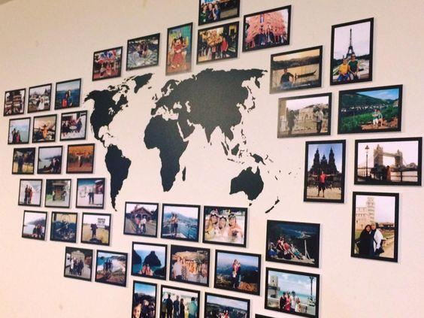
Materials and/or tools needed: | A printer (for Α0, A4, A3, A5 paper)  A4, A3, A5 photographic paper  Α0 cardboard  Blu tack or double-sided tape  There will be a general explanatory label taped on the wall.
Dimensions: | Total wall surface, around 2x3 m (horizontal)
Step by step construction instructions: | - Download a general image of the relief of Mount Olympus (Suggestion: Google Earth)  - Print it on the A0 cardboard and stick it in the center of the wall  - Download at least 4 photos depicting tree species or forests characteristic of the vegetation zones of Olympus. The POEME e-Worksheet can help you with this [Suggestion to download further material: Mount Olympus: Birds on Olympus (olympusnp.blogspot.com) or Flora - Fauna - Olimpos.eu or you can further use material from POEME e-worksheets available on POEME website)  - Edit each image by entering on it the name of the displayed species.  - Print the photos from step 3 in various dimensions A3, A4, A5 some vertical and some horizontal. Then, tape them around the central photo of Mount Olympus. It is a good idea to stick the species according to the altitude at which they grow (e. g. some higher, some lower)

Sub-section: | The unique Olympus
Exhibit number: | No 4
Name of the exhibit: | Art is inspired by nature
Type of exhibit: | Digital
Preparation time: | 1 week
Required students: | 3 students (in total)
Brief description: | A digital plants book containing samples of flowers of the typical flora of Olympus. Each page will have one species (flower sample with its scientific and common name written).  There will be a general explanatory label at first page.
Materials and/or tools needed: | Book Creator free on-line application (https://bookcreator.com/). The e-book will be presented through an electronic device (i.e., tablet with screen at least 10’’) placed on a table.
Dimensions or format or form: | ePub format (an online reader such as Thorium will be needed)  Screen at least 10’’
Step by step construction instructions: | - Compile the names of the flowers together with pictures that you will download from the internet. The POEME e-Worksheet can help you with this (Suggestion to download images: Flora - Fauna - Olimpos.eu or http://105dim-thess.thess.sch.gr/1051/files/endemic%20plants%20of%20Olympus.p)  - During the previous step, download images related to the text.  - Build the book in the app Book Creator based on the material you gathered. Each page will have 2 images of one species (flower sample with its scientific and common name written). Υou can add additional details for this species, e.g. if it is endemic or protected species.  - Save your file to a tablet.

Sub-section: | The unique Olympus
Exhibit number: | No 5
Name of the exhibit: | Let’s play with animals!
Type of exhibit: | Tangible (interactive)
Preparation time: | 2 hours for the preparation & 1 hour for the installation
Required students: | 4 students (in total)
Brief description: | A structure in which the fauna of Olympus is presented. Labels of names and some information are all permanently taped on strings in a bottom row and above them mixed images of animals are hung with pegs. The visitors are invited to put the images in the correct place based on the label that they will read. You can use 3-4 pairs of rows to fit all animal species.  See an example:  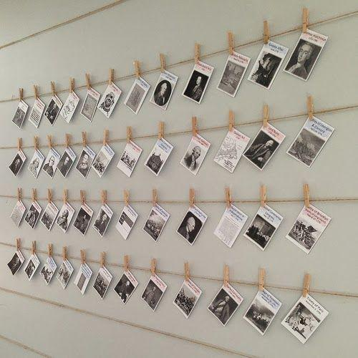  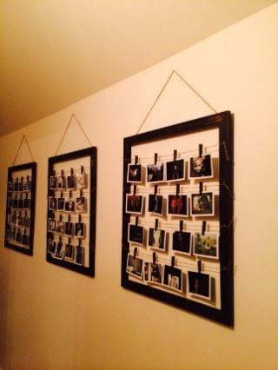
Materials and/or tools needed: | A printer, Α4 paper, photographic paper (size A5), pair of scissors, small wooden pegs, cord/string, nails-hammer, transparent tape  Alternatively: a large wooden frame
Dimensions of the construction: | Maximum width 2 meters / Maximum height 1 meter
Step by step construction instructions: | 1. Compile the names and some information for the animal species together with pictures that you will download from the internet. The POEME e-Worksheet can help you with this (Suggestion: https://www.olimpos.eu/olimpos/life_nature/ or Olympus Mountain Refuge A ~ Image Gallery (mountolympus.gr) and ΟΛΥΜΠΟΣ. ΤΟ ΒΟΥΝΟ ΤΩΝ ΘΕΩΝ ΚΑΙ ΤΩΝ ΑΝΘΡΩΠΩΝ. ΧΛΩΡΙΔΑ (mountolympos.gr).  2. Print the pictures on photographic paper and cut them in a specific dimension (A5)  3. During the above steps, cut and hang rows of cords on the wall or fasten them inside a wooden frame which you will hang on the wall.  4. Print the labels on A4 paper. Each label should have dimensions of 6x15 cm and should include the scientific and common name of the animal along with some basic information. The relevant POEME e-Worksheet can help you with this.  5. Tape the labels in fixed places on the bottom rows.  6. Hang with pegs the pictures of animals mixed up in the empty rows.

Sub-section: | Mountain of Gods
Exhibit number: | No 6
Name of the exhibit: | The residence of the 12 ancient Greek gods
Type of exhibit: | Digital (interactive)
Preparation time: | 1 week
Required students: | 3 students
Brief description: | An e- book will be created, which will present excerpts from ancient texts by Homer, the history of the mountain with references to Greek mythology, the 12 Greek Gods, the worship of the mountain and the role it played during wars. There will be a general explanatory label at first page.
Materials and/or tools needed: | Book Creator free on-line application (https://bookcreator.com/). The e-book will be presented through an electronic device (i.e. tablet) placed on a table.
Format: | ePub format (an online reader such as Thorium will be needed)  Screen at least 10’’
Step by step construction instructions: | - Search for internet information on the history of Olympus, the 12 Gods, the Homeric Epics, the mountain as a place of worship. Based on these elements, write a narrative text. The POEME e-Worksheet can help you with this (Suggestion: https://www.olimpos.eu/olimpos/life_nature/ or Μυθολογία – Ιστορία | Olympus Travel Guide).  - During the previous step, download images related to the text.  - You can add a video about Greek mythology. Mount Olympus: The Great Palace Of The Gods - Greek Mythology Explained - YouTube  - Build the book in the app Book Creator based on the material you gathered and the narrative text that was produced at step 1..  - Save your file to a tablet.

Sub-section: | Mountain of Gods
Exhibit number: | No 7
Name of the exhibit: | Olympus has fallen…
Type of exhibit: | Tangible
Preparation time: | 2 hours total
Required students: | 3 students in total
Brief description: | A structure resting on a tree branch from which black and white photographs in two dimensions (A5, A4), horizontally and vertically, are hang from strings. The photographs show the conquest of the summit of Olympus, through the photo collection of Frédéric Boissonnas.
Materials and/or tools needed: | A printer, photographic paper (size A4, A5), pair of scissors, a tree branch, cord/string, nails-hammer. There will be a general explanatory label taped on the wall.
Dimensions of the construction: | Branch length: 2 meters  Maximum height of the construction: 1,5 m
Step by step construction instructions: | - Download at least 6 black-white photos from the photo album of Frédéric Boissonnas. (Suggestion to download material: https://greekreporter.com/2022/07/07/frederic-boissonnas-photographer-greece/ and https://www.dion-olympos.gr/frederic-boissonas-1858-1946/ )  - Print the above photos in two dimensions A4, A5 some vertical and some horizontal.  - Find a natural tree branch and tie as many strings to it as the photos you selected. The strings should be at different heights each.  - Make a small hole in each photo and tie it to the corresponding string, making sure they don't fall on top of each other.

Sub-section: | Mountain of Gods
Exhibit number: | No 8
Name of the exhibit: | Church... on high
Type of exhibit: | Digital
Preparation time: | 1 hour total
Required students: | 2 students
Brief description: | A short video (02:25min) showing the incredible view from the peaks of Olympus and specifically from 01:45 it focuses on the tallest chapel in Balkans. The video will be displayed on a TV screen nonstop during the exhibition.
Materials and/or tools needed: | A smart tv based on the wall or on a stable table (alternatively you can use a projector and a computer).  A YouTube video  There will be a general explanatory label taped on the wall.
Dimensions or format or form: | The tv screen should be at least 32’’
Step by step construction instructions: | - Install the TV on the wall or on a base like a table.  - Find the proper video. (Suggestion: Όλυμπος | Ένα μυθικό ταξίδι με drone στο βουνό των 12 θεών - YouTube)  - Download the Video and have it play in a loop.

Sub-section: | Respect for nature
Exhibit number: | No 9
Name of the exhibit: | The man and the mountain
Type of exhibit: | Tangible
Preparation time: | 2 days for the preparation & 1 hour for installation
Required students: | 4 students in total
Brief description: | 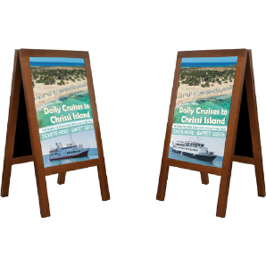  A construction in which two vertical large posters will be presented. One will display a map of Olympus with suggested climbing routes, the other will be a sign of regulations governing the National Park. See the above examples:  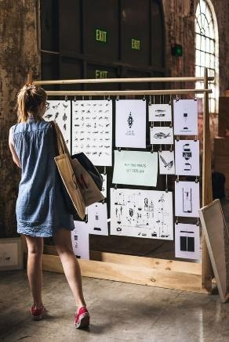  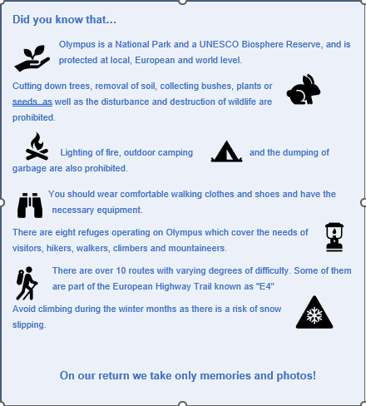  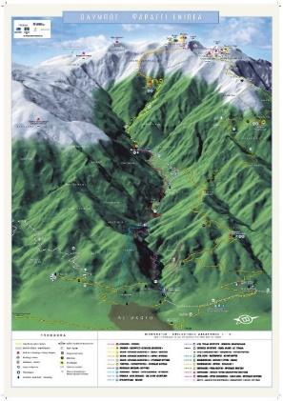
Materials and/or tools needed: | For the base construction:  A floor wooden frame (dimensions 1.80x60-horizontal) -> it would be nice to be made by a carpenter (see picture above)  Ropes and black clips  If this is not possible, you can use a portable bulletin board in the school (see picture above)  For the posters:  A printer for A3 photographic paper  A3 photo paper  There will be a general explanatory label hung on the wall.
Dimensions: | Each poster size A3
Step by step construction instructions: | - Download one map of Mount Olympus showing the possible climbing routes. (Suggestion: Hiking - Routes - Olimpos.eu or Hiking Map of mount Olympus (leivaditis.gr) and Ορειβατικές Διαδρομές | Olympus Travel Guide and http://oreivatein.blogspot.com/2012/08/blog-post.html ). You can use the website https://pixlr.com/gr/x/ in order to edit your image at the desired quality and size.  - Create a poster sign showing the protection status of Olympus and the main regulations. You can get ideas from the POEME e-Worksheet as well as from Εθνικός Δρυμός Ολύμπου | Olympus Travel Guide. You can use a template from https://www.canva.com/  - Print the above images from steps 1 & 2 at size A3 each.  - Hang the posters on the structure of your choice (either on the one made in a carpentry, or on a notice board you borrowed from school).

Sub-section: | Respect for nature
Exhibit number: | No 10
Name of the exhibit: | So many things to dο!
Type of exhibit: | Intangible (Act/Performance) and digital background
Preparation time: | 2 days for the preparation of the act & 1 hour for the video  The act should not be more than 10 minutes.
Required students: | 3 students (2 of them as actors)
Brief description: | The exhibit is a combination. It consists of projecting a video on the wall (as a background) that shows all the activities that a visitor of Mount Olympus can do. In front of it there is a small stage (2x3 m) where two actors play a short sketch in which they also involve the audience (role play activity). One of the two is a mountain instructor and the other is a student who is interested in going on a mountain trip with his friends. Questions are asked to find out what they are allowed to do and what they are not allowed to do.
Materials and/or tools needed: | A lap top, a projector and a YouTube video  There will be a general explanatory label taped on the wall.
Dimensions or format or form: | A small stage 2x3 m
Step by step construction instructions: | - Place the lap top on a small table and connect it with a projector.  - Find the website: Olympus | A mythical escape of mountain & sea - YouTube & display it on the wall at the background.  - Prepare a small dialogue for the actors and some questions for the audience.

Sub-section: | Respect for nature
Exhibit number: | No 11
Name of the exhibit: | A good climber is a well prepared one
Type of exhibit: | Tangible
Preparation time: | 1 week (in order to find the objects and place them)
Required students: | 6 students in total
Brief description: | The exhibit is a mountain camping scene, centered around an igloo tent. Around it is camping/mountaineering objects.
Materials and/or tools needed: | Real objects: small backpack, water/windproof jacket, fleece jacket, mountaineering boots, sunglasses, mountaineering shocks, hats, headlight, whistle, compass, map, sleeping bag, water flask, a tent.  Ropes, pair of scissors, little labels with the name of the object written on them.
Dimensions: | Occupy the center of the exhibition as it will be a representation of camping on the mountain. Sufficient space is required depending on the room. To save space, it is suggested that some of the objects be hung from the ceiling with a rope.
Step by step construction instructions: | - Find the required objects.  - Place them in the exhibition.

