Structure/content of a blended exhibition
STEP 1: Plan the theme, set the goals
Main theme of the exhibition: | Presentation of Mount Olympus in Greece, as a natural monument of UNESCO cultural heritage. The exhibition focuses on the natural environment of Mount Olympus and its outstanding universal cultural value, in such a way that students gain ecological awareness through experiential learning.
Educational goals of the exhibition: | - Enrich students’ vocabulary about natural environment and make them comfortable with written and spoken language,  - Enhance students’ collaboration with each other through the creation of exhibits,  - Showcase their talents and skills (digital, presentation etc.) and strengthen their self-confidence,  - Strengthen students’ respect for the natural environment and gain ecological awareness.

STEP 2: Develop sub-themes
Sub-sections | Sub-themes
- The unique Olympus | General description of the mountain  Landscapes  Flora and fauna
- Mountain of Gods | History & mythology  Mount Olympus as a worldwide symbol  Monuments & buildings
- Respect for nature | Legal protection status  Do’s and don’ts when visiting a protected area  The characteristics of a good climber
STEP 3: Create an object list
 | Name of the object | Type | Sub-section | Creation
1. | Video presentation of the mountain | Digital | The unique Olympus | ΝΟ
2. | Interactive presentation of the peaks | Digital | The unique Olympus | ΝΟ
3. | Art gallery of forests/trees | Tangible | The unique Olympus | YES
4. | Plants book | Digital | The unique Olympus | YES
5. | Interactive photo gallery of animals | Tangible | The unique Olympus | YES
6. | Ε-book excerpts from Greek mythology/history | Digital | Mountain of Gods | YES
7. | Old-Photos gallery | Tangible | Mountain of Gods | YES
8. | Video presentation of an ancient church | Digital | Mountain of Gods | NO
9. | Map of Olympus Mountain trails & Regulation sign | Tangible | Respect for nature | YES
10. | Presentation & role play activity: interview | Intangible and digital | Respect for nature | NO
11. | Mountain clothing & equipment | Tangible | Respect for nature | NO
STEP 4: Design your exhibition
The exhibition for Mount Olympus will take place live in a large school hall. The visitors enter having the exhibits on their right side. They meet the first sub-section and see an introductory video (Exhibit 1), then move forward to Exhibit 2 where they can spend some time browsing the peaks. After that, the visitors move along the wall to see an art/photo gallery of forests (Exhibit 3) and beside that they find a plants book and each visitor can flip through the pages (Exhibit 4). The first sub-section ends with the photographic presentation of the fauna through a game (Exhibit 5). The second sub-section begins with an e-book (Exhibit 5) on the vertical shorter side of the hall and continues with a photo-gallery (Exhibit 7) and a video presentation (Exhibit 8). At the third and last long side of the hall, there is the third sub-section that begins with a map of the mountain trails (Exhibit 9). After that, the visitors make a brief stop at the next Exhibit 10 which combines presentation and role play and requires space and time. The exhibition is completed with Exhibit 11, where the visitors walk among real climbing objects.
See the proposed sketch.

Entrance/Exit

The unique Olympus
Mountain of Gods
Respect for nature
1
10
9
5
8
4
2
3
6
11
7
11

Sub-sections | Object arrangement | Object display
The unique Olympus | 1. Video presentation of the mountain | Display on a TV screen nonstop (in a loop)
 | 2. Interactive presentation of the peaks | Α computer with a large screen on a table. Ideally, an interactive whiteboard.
 | 3. Art gallery of forests/trees | Large poster of Mount Olympus attached to the wall and many images stuck to specific places of the poster.
 | 4. Plants book (interactive) | An e-book presented through a tablet on a table.
 | 5. Interactive photo gallery of animals | A construction on the wall made by strings on which there are animal names and explanatory captions, and students are asked to put the correct photo of the animal above each text.
Mountain of Gods | 6.Ε-book with excerpts from Greek mythology and history of the mountain (interactive) | An e-book presented through a tablet on a table.
 | 7. Old-photos gallery | Black and white photos of various sizes hung with ropes from a branch.
 | 8. Video presentation of an ancient church | Display on a TV screen nonstop (in a loop)
Respect for nature | 9. Map of Olympus Mountain trails and Regulation sign | Map and sign stuck on a floor wooden board 1.80x60 (vertical) or a school notice board.
 | 10. Video & role play activity | On a small stage 2x3 meters: 2 actors, scenic background: display of a video on the wall
 | 11.Mountain clothing & equipment | Real climbing objects and equipment, some suspended by ropes from the ceiling and some in ready-made scenery, e.g., a camping tent.
STEP 5: Develop texts
Panels

MOUNT OLYMPUS

Olympus is the highest mountain in Greece. According to the Greek mythology it was the home of the 12 ancient Greek Gods & Goddesses.
In 1938 Olympus was established as Greece’s first National Park due to its natural and cultural value.
Nowadays visitors come from all over the world. They admire its history and rare beauty.

The Unique Olympus
At high altitude there are meadows or rocky slopes. At lower levels there are different kind of forests with beeches and black pines.
More than 1,100 species of flora have been recorded.
Its forests are home to a multitude of animals, some of which are rare or endangered.

Respect for nature
Olympus is a National Park and a UNESCO Biosphere Reserve, protected in national, European and world level.
Since the 1960s mountain tourism evolved gradually on its trails. Ascending Mount Olympus requires physical and mental stamina, proper clothing and equipment and most of all respect for the features of this unique mountain.
Mountain of Gods
The shape of Olympus and its high and steep peaks usually covered by fog and stormy clouds have fascinated people since prehistoric times.
This mountain always aroused curiosity and admiration. That is why ancient Greeks chose this place as residence of their 12 Gods. Poets, writers and painters faced its mystery with awe.
Due to the sanctity of the place, human settlements were limited to its foothills.

Object labels (samples)
Alternatively, you can use QR codes in the label to provide more information.
Exhibit 1 (taped on the wall)
An experience of a lifetime
As you approach the peaks you feel like a little god. Climbing Mount Olympus is a mythical escape that remains an unforgettable experience. The mountain has a lot to teach you.

Exhibit 2 (taped on the wall)
Climb the peaks!
Steep and almost always cloudy, the peaks of Olympus take your breath away. The highest is Mytikas (2,918 m.) which according to mythology was the meeting point of the Gods of Olympus. Other familiar peaks are Stefani (2,909 m.), known as the throne of Zeus from which he threw his lightning; Agios Antonios (2,815 m.) where the ancient Greeks had arrived to have eye contact with Mytikas and to leave their tributes to Gods; Prophet Elias (2,803 m.) with the orthodox chapel in the place where it is said that it was the temple of the god Apollo. Between the peaks, at 2,550 m. altitude there is a beautiful meadow where the Muses lived.

Exhibit 3 (taped on the wall near each photo)
Green forests everywhere!
The variety of microclimates is responsible for the inversion of vegetation zones and for the anarchy of the vegetation zones distribution. The highest tree‐line (timber‐line) in Europe occurs on this mountain (Pinus heldreichii at 2500 m). There are generally four successive zones of vegetation observed on Olympus without clear boundaries between them and they are as follows: Mediterranean vegetation zone, Zone of beech-fir and mountain conifer forests, Zone of cold-lived conifers, Exodus zone of high mountains.

Exhibit 4 (stuck on the table)
Art is inspired by nature
Olympus has a special ecological value with a plethora of rare, local endemic plants that are unique in the world.

Exhibit 5 (stuck on the board)
Let’s play with animals!
The fauna of Olympus includes significant diversity and is characterized by the presence of important, rare and endangered species. The large mammals that once lived in the area, such as the deer, have now disappeared. In antiquity there were lions, while at least until the 16th century there were bears. Nowadays, 32 species of mammals have been recorded, including: the ibex (Ryricapra rupicapra), the roe deer (Capreolus capreolus), the wild boar (Sus scrofa), the wildcat (Felis sylvestris), the marten (Martes foina), the fox (Vulpes vulpes), the squirrel (Sciurus vulgaris).
108 species of birds have also been identified (such as grebe, black vulture, partridge, white stork, wood pigeon, robin, golden heron, peregrine falcon, grebe, golden eagle, osprey) many of which, especially the raptors, are rare and strictly protected by international contracts.
There are still the usual reptiles of the Greek area (22 species such as snakes, turtles, lizards, etc.) and some amphibians (8 species) in the streams and seasonal lakes, as well as a large variety of insects, mainly butterflies, for which the Olympus is famous.

Exhibit 6 (stuck on the table)
The residence of the 12 ancient Greek gods
Archaeological findings go back to the Iron Age and prehistoric people chose to live in the foothills of this glorious mountain. Inspired by its mystery, the ancient Greeks created the legends that gave birth to the Twelve Greek gods: Zeus and Hera, their siblings Hestia, Demeter, Poseidon and their seven children Athena, Apollo, Artemis, Hermes, Ares, Aphrodite and Hephaestus.
According to Homer, the twelve gods lived in ravines in “the mysterious folds of Olympus”, where they had their palaces. In Homer’s “Iliad”, Mount Olympus is described as “magnificent”, “long”, “glorious” “glistering” and “full of trees”. Pantheon (today’s Mytikas-the highest peak of Mount Olympus) was their meeting place. Their tempestuous arguments were apparently heard by the “god of gods”, Zeus, sitting on his imposing throne (today’s Stefani). From there he unleashed his thunderbolts, displaying “his godly wrath”.
According to tradition and research, ceremonies and rituals were also carried out on the peaks of Mount Olympus. This has been confirmed by findings (marble columns with inscriptions, ceramics, coins, remnants of offerings) which connect the mountain with the worship of the gods.
The history of Mount Olympus continued being turbulent under the Turkish occupation. The mountain was a hiding place for the famous “Armatol” (brave Greek resistance fighters), who fought against the “yoke of the tyrant”, the Ottoman Empire. During the German invasion in 1941, the Greek army fought important battles. Later in the war, Greek Resistance found a secure place of refuge there.

Exhibit 7 (stuck on the wall)
Olympus has fallen…
It took a century and 25 failed attempts before the tallest peak of ancient Greece's most sacred mountain was conquered. The attempts were continuous, until August 2, 1913, when two Swiss, Fred Boissonnas and Daniel Beau-Bovy, led by the local hunter Christos Kakalos, set foot on the highest peak of Olympus, Myticas (2,918 m.).

Exhibit 8 (stuck on the wall)
Church…on high
Prophet Elias is the tallest chapel in the Balkans. It is located on the Plateau of the Muses, at an altitude of 2803 meters, at the homonymous peak. It was first built by Saint Dionysios in the 16th century. Today it has been rebuilt.

STEP 6: Construct your exhibition & exhibits
Sub-section: | The unique Olympus
Exhibit number: | No 1
Name of the exhibit: | An experience of a lifetime
Type of exhibit: | Digital
Preparation time: | 1 hour total
Required students: | 2 students (in total)
Brief description: | A short video (07:12min) showing the mountain from the foothills to the top. The video will be displayed on a TV screen nonstop during the exhibition.
Materials and/or tools needed: | A smart tv based on the wall or on a stable table (alternatively you can use a projector and a computer).  A You Tube video about Mount Olympus.  There will be a general explanatory label taped on the wall.
Dimensions of the exhibit: | The tv screen should be at least 50’’
Step by step construction instructions: | - Install the TV on the wall or on a base like a table.  - Find the proper video. (Suggestion: Ανάβαση στον Όλυμπο: Οροπέδιο Μουσών - Προφήτης Ηλίας - Λούκι - Μύτικας - Ζωνάρια - Πριόνια (2018) - YouTube)  - Download the Video and have it play in a loop

Sub-section: | The unique Olympus
Exhibit number: | No 2
Name of the exhibit: | Climb the peaks
Type of exhibit: | Digital (interactive)
Preparation time: | 1 hour total
Required students: | 2 students (in total)
Brief description: | A website that presents the peaks of Mount Olympus in 3D. Sitting in front of a computer or standing in front of an interactive whiteboard, the visitor has the opportunity to tour each peak, learn its altitude and enjoy the unique landscape.
Materials and/or tools needed: | Α computer with a large screen on a table. Ideally, an interactive whiteboard. There will be a general explanatory label taped on the wall.
Dimensions: | Computer screen no smaller than 23''
Step by step construction instructions: | - Place the computer on a small table  Find the website (Εθνικός Δρυμός Ολύμπου - Mount Olympus Summits) & display it on the screen  - Don’t forget to put a chair in front of the computer  OR  1. Place the interactive board on the wall or on a proper base  2. Connect the board with a lap-top and a projector  3. Display the website on the screen  4. Don’t forget to leave enough space for the visitor to move in front of the board

Sub-section: | The unique Olympus
Exhibit number: | No 3
Name of the exhibit: | Green forests everywhere!
Type of exhibit: | Tangible
Preparation time: | 2 hours for preparation & 1 hour for the installation
Required students: | 4 students (in total)
Brief description: | A poster on which the mountain’s relief is printed having around pasted photos of various sizes showing different types of trees and forests.  See an example:  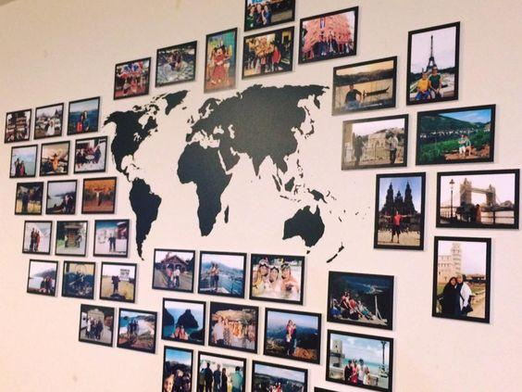
Materials and/or tools needed: | A printer (for Α0, A4, A3, A5 paper)  A4, A3, A5 photographic paper  Α0 cardboard  Blu tack or double-sided tape  There will be a general explanatory label taped on the wall.
Dimensions: | Total wall surface, around 2x3 m (horizontal)
Step by step construction instructions: | - Download a general image of the relief of Mount Olympus (Suggestion: Google Earth)  - Print it on the A0 cardboard and stick it in the center of the wall  - Download at least 4 photos depicting tree species or forests characteristic of the vegetation zones of Olympus. The POEME e-Worksheet can help you with this [Suggestion to download further material: Mount Olympus: Birds on Olympus (olympusnp.blogspot.com) or Flora - Fauna - Olimpos.eu or you can further use material from POEME e-worksheets available on POEME website)  - Edit each image by entering on it the name of the displayed species.  - Print the photos from step 3 in various dimensions A3, A4, A5 some vertical and some horizontal. Then, tape them around the central photo of Mount Olympus. It is a good idea to stick the species according to the altitude at which they grow (e. g. some higher, some lower)

Sub-section: | The unique Olympus
Exhibit number: | No 4
Name of the exhibit: | Art is inspired by nature
Type of exhibit: | Digital
Preparation time: | 1 week
Required students: | 3 students (in total)
Brief description: | A digital plants book containing samples of flowers of the typical flora of Olympus. Each page will have one species (flower sample with its scientific and common name written).  There will be a general explanatory label at first page.
Materials and/or tools needed: | Book Creator free on-line application (https://bookcreator.com/). The e-book will be presented through an electronic device (i.e., tablet with screen at least 10’’) placed on a table.
Dimensions or format or form: | ePub format (an online reader such as Thorium will be needed)  Screen at least 10’’
Step by step construction instructions: | - Compile the names of the flowers together with pictures that you will download from the internet. The POEME e-Worksheet can help you with this (Suggestion to download images: Flora - Fauna - Olimpos.eu or http://105dim-thess.thess.sch.gr/1051/files/endemic%20plants%20of%20Olympus.p)  - During the previous step, download images related to the text.  - Build the book in the app Book Creator based on the material you gathered. Each page will have 2 images of one species (flower sample with its scientific and common name written). Υou can add additional details for this species, e.g. if it is endemic or protected species.  - Save your file to a tablet.

Sub-section: | The unique Olympus
Exhibit number: | No 5
Name of the exhibit: | Let’s play with animals!
Type of exhibit: | Tangible (interactive)
Preparation time: | 2 hours for the preparation & 1 hour for the installation
Required students: | 4 students (in total)
Brief description: | A structure in which the fauna of Olympus is presented. Labels of names and some information are all permanently taped on strings in a bottom row and above them mixed images of animals are hung with pegs. The visitors are invited to put the images in the correct place based on the label that they will read. You can use 3-4 pairs of rows to fit all animal species.  See an example:  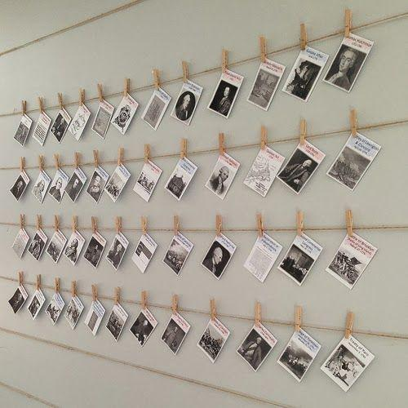  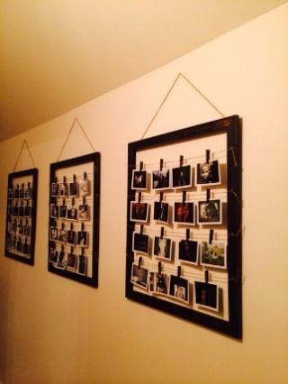
Materials and/or tools needed: | A printer, Α4 paper, photographic paper (size A5), pair of scissors, small wooden pegs, cord/string, nails-hammer, transparent tape  Alternatively: a large wooden frame
Dimensions of the construction: | Maximum width 2 meters / Maximum height 1 meter
Step by step construction instructions: | 1. Compile the names and some information for the animal species together with pictures that you will download from the internet. The POEME e-Worksheet can help you with this (Suggestion: https://www.olimpos.eu/olimpos/life_nature/ or Olympus Mountain Refuge A ~ Image Gallery (mountolympus.gr) and ΟΛΥΜΠΟΣ. ΤΟ ΒΟΥΝΟ ΤΩΝ ΘΕΩΝ ΚΑΙ ΤΩΝ ΑΝΘΡΩΠΩΝ. ΧΛΩΡΙΔΑ (mountolympos.gr).  2. Print the pictures on photographic paper and cut them in a specific dimension (A5)  3. During the above steps, cut and hang rows of cords on the wall or fasten them inside a wooden frame which you will hang on the wall.  4. Print the labels on A4 paper. Each label should have dimensions of 6x15 cm and should include the scientific and common name of the animal along with some basic information. The relevant POEME e-Worksheet can help you with this.  5. Tape the labels in fixed places on the bottom rows.  6. Hang with pegs the pictures of animals mixed up in the empty rows.

Sub-section: | Mountain of Gods
Exhibit number: | No 6
Name of the exhibit: | The residence of the 12 ancient Greek gods
Type of exhibit: | Digital (interactive)
Preparation time: | 1 week
Required students: | 3 students
Brief description: | An e- book will be created, which will present excerpts from ancient texts by Homer, the history of the mountain with references to Greek mythology, the 12 Greek Gods, the worship of the mountain and the role it played during wars. There will be a general explanatory label at first page.
Materials and/or tools needed: | Book Creator free on-line application (https://bookcreator.com/). The e-book will be presented through an electronic device (i.e. tablet) placed on a table.
Format: | ePub format (an online reader such as Thorium will be needed)  Screen at least 10’’
Step by step construction instructions: | - Search for internet information on the history of Olympus, the 12 Gods, the Homeric Epics, the mountain as a place of worship. Based on these elements, write a narrative text. The POEME e-Worksheet can help you with this (Suggestion: https://www.olimpos.eu/olimpos/life_nature/ or Μυθολογία – Ιστορία | Olympus Travel Guide).  - During the previous step, download images related to the text.  - You can add a video about Greek mythology. Mount Olympus: The Great Palace Of The Gods - Greek Mythology Explained - YouTube  - Build the book in the app Book Creator based on the material you gathered and the narrative text that was produced at step 1..  - Save your file to a tablet.

Sub-section: | Mountain of Gods
Exhibit number: | No 7
Name of the exhibit: | Olympus has fallen…
Type of exhibit: | Tangible
Preparation time: | 2 hours total
Required students: | 3 students in total
Brief description: | A structure resting on a tree branch from which black and white photographs in two dimensions (A5, A4), horizontally and vertically, are hang from strings. The photographs show the conquest of the summit of Olympus, through the photo collection of Frédéric Boissonnas.
Materials and/or tools needed: | A printer, photographic paper (size A4, A5), pair of scissors, a tree branch, cord/string, nails-hammer. There will be a general explanatory label taped on the wall.
Dimensions of the construction: | Branch length: 2 meters  Maximum height of the construction: 1,5 m
Step by step construction instructions: | - Download at least 6 black-white photos from the photo album of Frédéric Boissonnas. (Suggestion to download material: https://greekreporter.com/2022/07/07/frederic-boissonnas-photographer-greece/ and https://www.dion-olympos.gr/frederic-boissonas-1858-1946/ )  - Print the above photos in two dimensions A4, A5 some vertical and some horizontal.  - Find a natural tree branch and tie as many strings to it as the photos you selected. The strings should be at different heights each.  - Make a small hole in each photo and tie it to the corresponding string, making sure they don't fall on top of each other.

Sub-section: | Mountain of Gods
Exhibit number: | No 8
Name of the exhibit: | Church... on high
Type of exhibit: | Digital
Preparation time: | 1 hour total
Required students: | 2 students
Brief description: | A short video (02:25min) showing the incredible view from the peaks of Olympus and specifically from 01:45 it focuses on the tallest chapel in Balkans. The video will be displayed on a TV screen nonstop during the exhibition.
Materials and/or tools needed: | A smart tv based on the wall or on a stable table (alternatively you can use a projector and a computer).  A YouTube video  There will be a general explanatory label taped on the wall.
Dimensions or format or form: | The tv screen should be at least 32’’
Step by step construction instructions: | - Install the TV on the wall or on a base like a table.  - Find the proper video. (Suggestion: Όλυμπος | Ένα μυθικό ταξίδι με drone στο βουνό των 12 θεών - YouTube)  - Download the Video and have it play in a loop.

Sub-section: | Respect for nature
Exhibit number: | No 9
Name of the exhibit: | The man and the mountain
Type of exhibit: | Tangible
Preparation time: | 2 days for the preparation & 1 hour for installation
Required students: | 4 students in total
Brief description: | 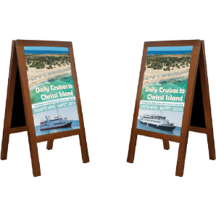  A construction in which two vertical large posters will be presented. One will display a map of Olympus with suggested climbing routes, the other will be a sign of regulations governing the National Park. See the above examples:  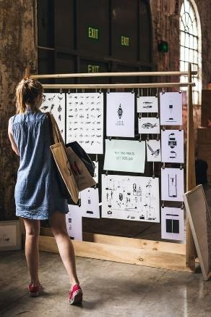  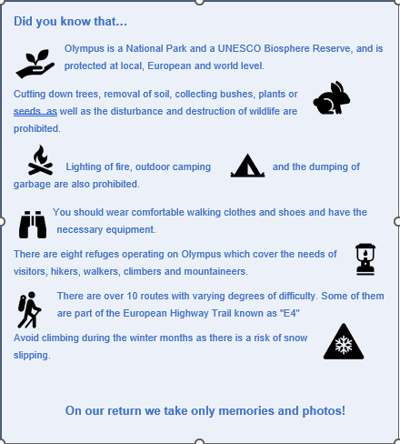  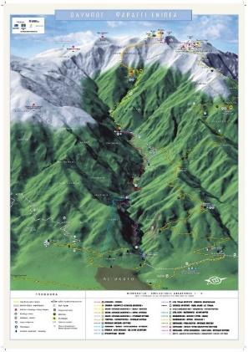
Materials and/or tools needed: | For the base construction:  A floor wooden frame (dimensions 1.80x60-horizontal) -> it would be nice to be made by a carpenter (see picture above)  Ropes and black clips  If this is not possible, you can use a portable bulletin board in the school (see picture above)  For the posters:  A printer for A3 photographic paper  A3 photo paper  There will be a general explanatory label hung on the wall.
Dimensions: | Each poster size A3
Step by step construction instructions: | - Download one map of Mount Olympus showing the possible climbing routes. (Suggestion: Hiking - Routes - Olimpos.eu or Hiking Map of mount Olympus (leivaditis.gr) and Ορειβατικές Διαδρομές | Olympus Travel Guide and http://oreivatein.blogspot.com/2012/08/blog-post.html ). You can use the website https://pixlr.com/gr/x/ in order to edit your image at the desired quality and size.  - Create a poster sign showing the protection status of Olympus and the main regulations. You can get ideas from the POEME e-Worksheet as well as from Εθνικός Δρυμός Ολύμπου | Olympus Travel Guide. You can use a template from https://www.canva.com/  - Print the above images from steps 1 & 2 at size A3 each.  - Hang the posters on the structure of your choice (either on the one made in a carpentry, or on a notice board you borrowed from school).

Sub-section: | Respect for nature
Exhibit number: | No 10
Name of the exhibit: | So many things to dο!
Type of exhibit: | Intangible (Act/Performance) and digital background
Preparation time: | 2 days for the preparation of the act & 1 hour for the video  The act should not be more than 10 minutes.
Required students: | 3 students (2 of them as actors)
Brief description: | The exhibit is a combination. It consists of projecting a video on the wall (as a background) that shows all the activities that a visitor of Mount Olympus can do. In front of it there is a small stage (2x3 m) where two actors play a short sketch in which they also involve the audience (role play activity). One of the two is a mountain instructor and the other is a student who is interested in going on a mountain trip with his friends. Questions are asked to find out what they are allowed to do and what they are not allowed to do.
Materials and/or tools needed: | A lap top, a projector and a YouTube video  There will be a general explanatory label taped on the wall.
Dimensions or format or form: | A small stage 2x3 m
Step by step construction instructions: | - Place the lap top on a small table and connect it with a projector.  - Find the website: Olympus | A mythical escape of mountain & sea - YouTube & display it on the wall at the background.  - Prepare a small dialogue for the actors and some questions for the audience.

Sub-section: | Respect for nature
Exhibit number: | No 11
Name of the exhibit: | A good climber is a well prepared one
Type of exhibit: | Tangible
Preparation time: | 1 week (in order to find the objects and place them)
Required students: | 6 students in total
Brief description: | The exhibit is a mountain camping scene, centered around an igloo tent. Around it is camping/mountaineering objects.
Materials and/or tools needed: | Real objects: small backpack, water/windproof jacket, fleece jacket, mountaineering boots, sunglasses, mountaineering shocks, hats, headlight, whistle, compass, map, sleeping bag, water flask, a tent.  Ropes, pair of scissors, little labels with the name of the object written on them.
Dimensions: | Occupy the center of the exhibition as it will be a representation of camping on the mountain. Sufficient space is required depending on the room. To save space, it is suggested that some of the objects be hung from the ceiling with a rope.
Step by step construction instructions: | - Find the required objects.  - Place them in the exhibition.

