Golden Age of Acropolis - Structure/content of a blended exhibition
STEP 1: Plan the theme, set the goals
Main theme of the exhibition: | The centerpiece of the exhibition is the Acropolis of Athens in Greece during the Golden Age. This era holds a remarkable universal value and heralds the beginning of classical Greek thought and art. Greek Antiquity comes alive in front of your eyes by presenting the Acropolis’s significant monuments through digital technologies and the Acropolis’s museum.
Educational goals of the exhibition: | - Learn about the importance and the rich antiquity of the Golden Age of the Acropolis  - Make use of digital technologies and have a unique experience by exploring the Acropolis  - Enrich students' vocabulary with a variety of words, with a focus on museum vocabulary  - Strengthen students’ respect for world heritages sites and highlight the importance of preserving them
STEP 2: Develop sub-themes
Sub-sections | Sub-themes
The Classical Age | Introduction to the Classical Period  History of Pericles  Acropolis
Acropolis and its monuments | The Parthenon  Other monuments of the Periclean building program
Acropolis Remembrance | Acropolis Virtual Tour  Live simulation of the Acropolis Hill
STEP 3: Create an object list
 | Name of the object | Type | Sub-section | Creation
1. | Photo Gallery of the Golden Age, Pericles and Acropolis | Tangible | The Classical Age | YES
2. | 360⁰ short Video of Acropolis Hill | Digital | The Classical Age | NO
3. | Photo Gallery - Monuments of the Acropolis | Tangible and Digital | Acropolis and its monuments | YES
4. | Short video of the Parthenon | Digital | Acropolis and its monuments | NO
5. | Acropolis Virtual Tour Website | Digital | Acropolis Remembrance | NO
6. | “Who is it” | Tangible | Acropolis Remembrance | YES
STEP 4: Design your exhibition
Floorplan: https://www.canva.com/design/DAFVSwQzgbA/DAVWfZsRIuyVu-J186PH2g/edit?utm_content=DAFVSwQzgbA&utm_campaign=designshare&utm_medium=link2&utm_source=sharebutton
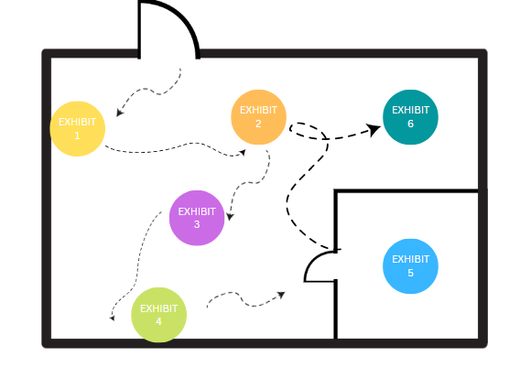
Sub-sections | Object arrangement | Object display
The Classical Age | Photo Gallery of the Classical Age, Pericles, and Acropolis | Large framed pictures of various dimensions, with small descriptions on their side. Pictures will be hung on the wall.
 | 360⁰ short Video of Acropolis Hill | Video from Youtube, will be scanned with its QR code, in a plexiglass case. Place it on a small table or on a stool. An explanatory text should be on the side with a tutorial involved. Cardboard VR goggles must be provided that are eligible for phones.
Acropolis and its monuments | Photo Gallery - Monuments of the Acropolis (In total 4) | Large posters that include a photo, a description, and a QR code, all taken from the Acropolis museum website. Hang the posters from the ceiling, by attaching ceiling hooks and rope to the picture. Pictures should be at least 1,5 meters from the floor.
 | Short video of the Parthenon | Display on a big TV screen nonstop.
Acropolis Remembrance | Acropolis Virtual Tour | Project on a wall the website of the acropolis virtual tour. The creation of a small dark room is needed for the best experience. Place a laptop -or computer in the center of the room and connect it to the projector.
 | Who is It? | The all-time classic fun game “Who Is It”, inspired by Acropolis. Print small pictures in small sizes portraying both the ancient ruins and famous people. Have participants choose randomly one and try to find out what are they, by asking yes/no questions.

STEP 5: Develop texts
Panels
Object labels

The Golden Age of the Acropolis

The Golden Age of the Acropolis took place in Greece between the fifth and fourth centuries B.C.E. This era is marked to be the cultural peak of Athens that gave us the great monuments, art, philosophy, architecture and literature we have today. During this prosperous period, Pericles was the leader, and with his massive building project, the Parthenon was built on the Acropolis, and the city became the artistic, cultural, and intellectual center of the Hellenic world.

The Classical Age

The Greeks reached new heights in art, architecture, theater, and philosophy during the Classical Period of ancient Greece. Under Pericles' leadership, democracy in Athens was refined. One of the most spectacular achievements in Athens during this period was the rebuilding of the Parthenon, a temple dedicated to Athena on the Acropolis.

Acropolis and its Monuments

The Acropolis of Athens and its monuments are universal symbols of the classical spirit and civilization, forming the world's greatest architectural and artistic complex bequeathed by Greek Antiquity. Under Pericles' rule, two well-known architects, Callicrates and Ictinus, as well as famed sculptor Phidias, assisted in the planning and execution of his building program, the Pericles' plan. The most important monuments were built during that time: the Parthenon, the Erechtheon, the Propylaea, the monumental entrance to the Acropolis, the statue of Athena Promachos and the small temple Athena Nike.

Acropolis Remembrancer

Discover Ancient Athens the way it was meant to be seen! Visit the Acropolis ruins and the magnificent Parthenon. With this comprehensive virtual tour of the Acropolis, you can delve deep into the ancient world.
The magnificent Acropolis ruins, which include the Erectheion, the Temple of Athena Nike, and, of course, the famous Parthenon, have left their imprint on architecture all over the world, inspiring everything from government buildings to banks to monuments.

Exhibit 1 (taped on the wall)

- The Acropolis of Athens is one of the world's most famous ancient archaeological sites. The Acropolis, located on a limestone hill high above Athens, Greece, has been inhabited since prehistoric times. The Acropolis has served as a king's residence, a citadel, a mythical home of the gods, a religious center, and a tourist attraction over the centuries. It has survived bombardment, massive earthquakes, and vandalism and still stands as a reminder of Greece's rich history. It is now a UNESCO World Heritage site with several temples, the most famous of which is the Parthenon.

- The age began with the unexpected defeat of a vast Persian army by outnumbered Greeks and ended with an ignoble and prolonged war between Athens and Sparta. This period is also known as the "Age of Pericles," after the Athenian statesman who oversaw Athens' affairs when it was at its peak. Pericles launched a massive building project that lasted 50 years in order to restore the Acropolis to its former glory.

- Pericles was born into one of Athens' most prominent families during the golden age of classical Greece. He was elected strategos (one of Athens' leading generals) in 443 and held that position for the rest of his life. Under Pericles' leadership, the so-called golden age of Athenian culture flourished (495-429 B.C.)

- The Greeks reached their greatest heights during the Classical Period. It gave us Socrates who steered philosophy in the direction of morals, logic and ethics. The physician Hippocrates, the sculptor Phideas, the architects of the Parthenon. One of the greatest inventions of the ancient Greeks was drama. Greek tragedies, featuring historical and mythological events, were written and directed by authors such as Aeschylus, Sophocles and Euripides. All of them contributed to an era that truly deserves to be called “golden”

Exhibit 2 (taped on the wall)
- The Acropolis, the greatest and finest sanctuary of ancient Athens, dominates the modern city center from the rocky crag known as the Acropolis.This sacred precinct is linked to the most celebrated myths of ancient Athens, its greatest religious festivals, earliest cults, and several pivotal events in the city's history. The Acropolis monuments are in harmony with their natural surroundings. These one-of-a-kind ancient architectural masterpieces combine different orders and styles of Classical art in a most innovative way, influencing art and culture for centuries.

Exhibit 3 (accompany each photo)
- The temple of Athena Nike was built between 426 and 421 BC on a bastion at the southwestern edge of the Acropolis by the architect Kallikrates. It replaced older temples, the remains of which are preserved within the bastion. On each side of the small Ionic temple was a relief-carved frieze with different thematic representations. The east side depicted a gathering of gods around the enthroned Zeus, while the other sides depicted war scenes between Greeks and Persians or Greeks with other Greeks. The south side depicted the Greeks' victory over the Persians at Marathon in 490 BC, led by the Athenians. Few sculptural remnants of the temple's pediments have survived. The west pediment is thought to depict the Olympian gods' victory over the Giants (Gigantomachy), while the east is thought to depict the Athenians' victory over the Amazons (Amazonomachy). For the protection of visitors, a marble parapet adorned with carved reliefs was installed around the dangerous edge of the temple's bastion around 410 BC. The reliefs depicted the seated goddess Athena resting after triumphant battles, watching winged Nikes lead bulls to sacrifice or holding weapons and decorating victory trophies with Greek or Persian armour.

- Between 437 and 431 BC, Mnesikles' monumental Propylaia, which replaced an earlier gate, was built as the entrance to the Acropolis sanctuary. However, because work ceased just before the Peloponnesian War in 431 BC, it was never finished. The structure had two side wings and a central entrance. Three sets of Ionic-style columns with exquisitely crafted capitals flanked the central opening. There were five entrances, the middle one being wider to allow for the Panathenaic procession and its sacrificed animals. The Pinakotheke, a large room with an anteroom, is located in the north wing. The name comes from a reference made by the 2nd-century BC traveler Pausanias to the paintings that once adorned this area and showed figures from Athens' mythical and historical past. Most likely, it was a reception area with couches and dining tables where VIP visitors could unwind and eat.

- The intricate Erechtheion was built in the final 20 years of the 5th century BC and was designed by the architect Mnesikles. It took the place of the "Archaios Neos" (Ancient Temple) of Athena Polias, which the Persians had partially destroyed sixty years earlier. The new temple was divided into two chambers: a lower western chamber that housed shrines to Poseidon-Erechtheus, Hephaistos, and Boutes, the brother of Erechtheus; and an upper eastern chamber that was devoted to Athena and contained the goddess' wooden cult statue.
- One of Pheidias' earliest works, The Athena Promachos, was once a well-known and celebrated Athenian landmark. Pausanias, a Greek traveler and cartographer, claimed that anyone approaching Athens from Attica at Sounion could see the top of Athena's helmet as well as the tip of her spear. The Athena Promachos, a statue made entirely of bronze, was referred to in antiquity as both "the bronze Athena" and "the great bronze Athena." The name "Promachos," which means "fighting before" or "in front of," was not initially applied to the statue; it was added later, most notably by Zosimus. For approximately 1000 years, Athena Promachos stood guard over her city, until shortly after 465 CE, when the sculpture was transported as a trophy to Constantinople (capital of the Eastern Roman Empire). Niketas Choniates documented a riot in Constantinople's Forum of Constantine in 1203 CE in which a large bronze statue of Athena was destroyed by a "drunken crowd," which is now thought to be the Athena Promachos.

Exhibit 4:
- The Parthenon is a magnificent marble temple built during the height of the Greek Empire between 447 and 432 B.C. The Parthenon, dedicated to the Greek goddess Athena, stands high atop the Acropolis of Athens, a complex of temples. It was the largest and most lavish temple ever built on the Greek mainland. The Parthenon has withstood earthquakes, fire, wars, explosions, and looting over the centuries and remains, albeit battered, a powerful symbol of ancient Greece and Athenian culture. It is now one of the most famous buildings in the world and a lasting symbol of ancient Greece.

Exhibit 5:
- The Parthenon, Propylaia, Erechtheion, and Temple of Athena Nike are among the most notable monuments featured in the Virtual Tour of the Acropolis Monuments. Additionally, there are detailed photographic displays of a few views taken from the outside of the hill's ancient walls. Descriptive information about the monuments and chosen points of interest is included with each view.

STEP 6: Construct your exhibition & exhibits
Sub-section: | The Classical Age
Exhibit number: | 1
Name of the exhibit: | The Classical Age
Type of exhibit: | Tangible
Recommended preparation time: | 1-2 hours
Required students: | 3
Brief description: | A photo gallery about the first sub-section. It will be 4 in total, printed and hung on the wall, accompanied by brief descriptions.
Materials and/or tools needed: | A printer that supports A2 size papers, tape
Dimensions of the exhibit: | All the pictures should be printed on A2 size paper (420x594 mm), horizontally.  The brief descriptive labels should be in “Arial” font, size 16.
Step by step construction instructions: | - Download the following pictures that represent the Classical Era, Perikleus, and the Acropoli  (a. Wallpaper Acropolis, Athens, Greece, sky, clouds, 5K, Travel #23357, b. Pericles | GONZOfoto | Flickr, c. Αρχείο:Pericles Pio-Clementino Inv269.jpg - Βικιπαίδεια, d. https://www.lookandlearn.com/history-images/A002051/The-Golden-Age-Athens-Crowning-Glory?img=4&search=Athens&cat=look-and-learn-collections&bool=phrase, )  - Print them and tape them, one next to the other on a wall  - Print the labels and place them underneath each picture.  - It should look like the following:  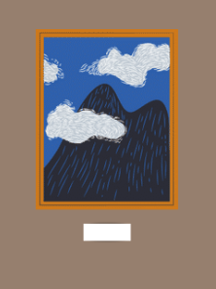

Sub-section: | The Classical Age
Exhibit number: | 2
Name of the exhibit: | Experience the Acropolis Hill
Type of exhibit: | Digital
Recommended preparation time: | 1 week (Depending on the delivery duration)
Required students: | 2
Brief description: | A 360⁰ video showing around Acropolis. Participants will scan a QR code with their phones and experience the video. VR goggles will be also provided.
Materials and/or tools needed: | Printer for the QR code, paper, a plexiglass case, 3 cardboard VR goggles, and this video (360° Explore the ancient Acropolis in Athens - BBC).
Dimensions of the exhibit: | The QR code dimensions should be 20x20 cm
Step by step construction instructions: | - Step: Order online these cardboard VR goggles: https://arvr.google.com/cardboard/get-cardboard/  - Print the QR code of the video  - Place it inside the plexiglass case  - Place the QR code with the 3 VR goggles on a small table or tool.  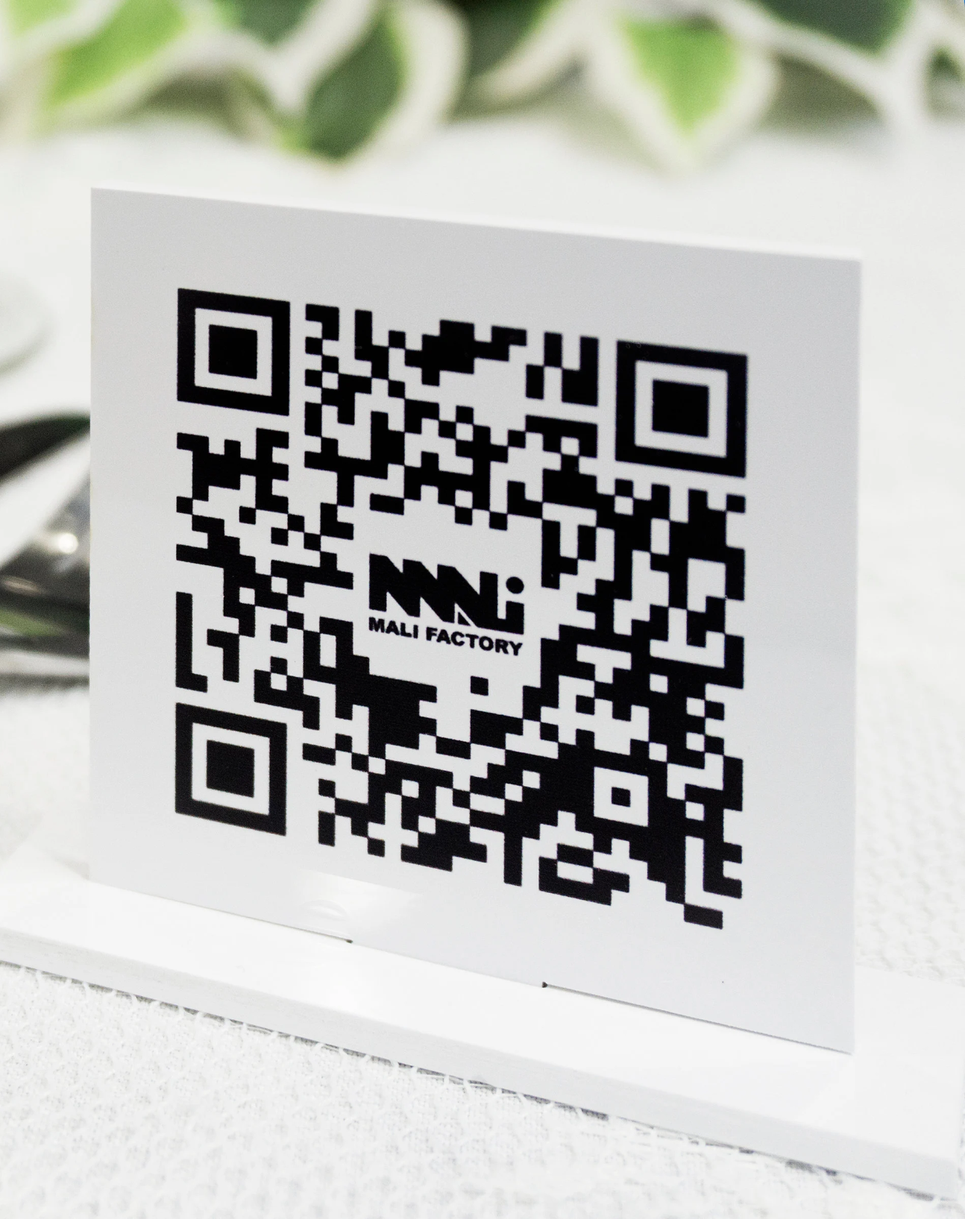

Sub-section: | Acropolis and its Monuments
Exhibit number: | 3
Name of the exhibit: | The monuments of Acropolis
Type of exhibit: | Tangible and Digital
Recommended preparation time: | 3 hours
Required students: | 5
Brief description: | A photo gallery with pictures and information from the Acropolis Museum Website
Materials and/or tools needed: | A printer that supports A0 size papers, papers, a large piece of string for hanging, black paper clips (at least 8), ceiling hoops with tape (at least 8).
Dimensions of the exhibit: | All the pictures should be printed on A0 size paper (841 x 1189 mm), vertically.
Step by step construction instructions: | - Step: Design each paper with a picture on the side, descriptive text, and a QR code that is linked to the museum website. The information will be mined by: The Temple of Athena Nike | Acropolis Museum | Official website , The Propylaia | Acropolis Museum | Official website , The Erechtheion | Acropolis Museum | Official website, Athena Promachos - Wikipedia ,  - Calculate the distance between the top of the photo and the ceiling. The bottom of the photograph should be 1,5m from the ground.  - Attach the ceiling hooks  - Cut the string and attach 2 on each piece of paper  - Hang them  Here are some example pictures to help you.  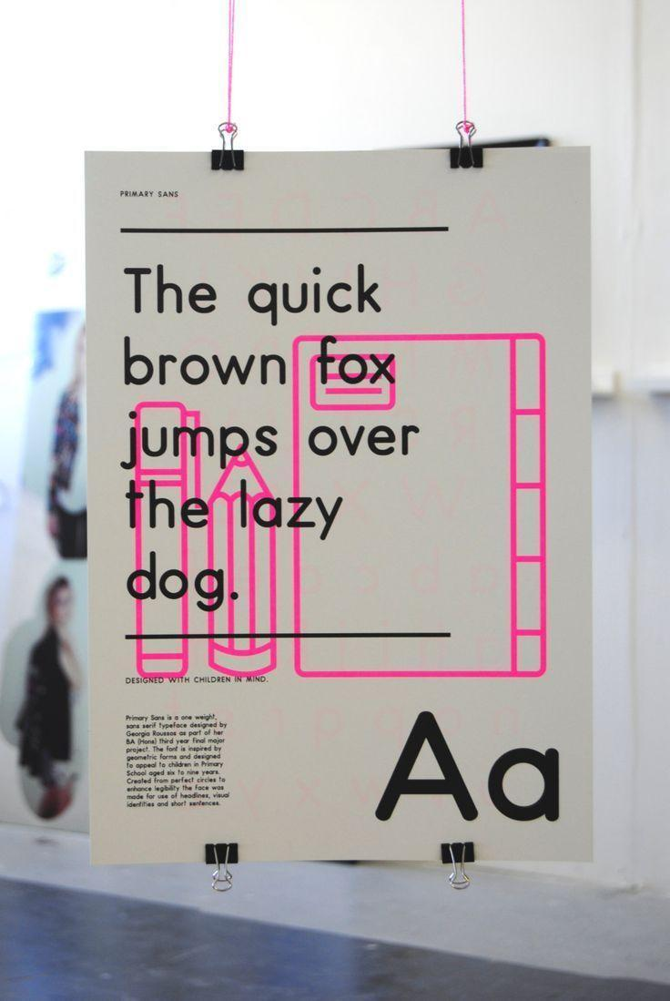  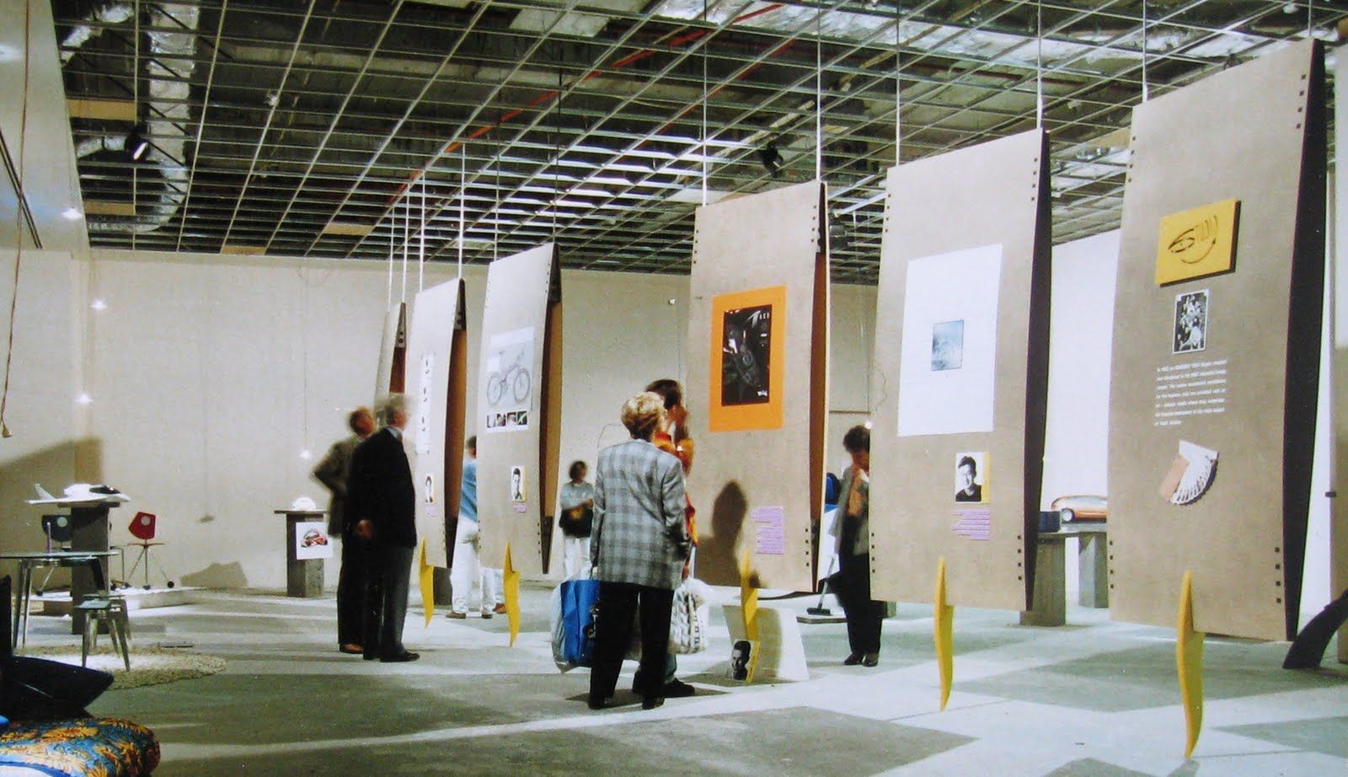

Sub-section: | Acropolis and its Monuments
Exhibit number: | 4
Name of the exhibit: | The Parthenon
Type of exhibit: | Digital
Recommended preparation time: | 3 hours
Required students: | 3
Brief description: | A short video about the Parthenon of the Acropolis
Materials and/or tools needed: | A Smart TV, tv wall base, the Parthenon video (The Parthenon - 3D reconstruction), floor pillows and pouffe cushions (6 -8).
Dimensions of the exhibit: | The TV device should be 75".
Step by step construction instructions: | - Install the TV on the wall  - Place the floor pillows/pouffe around the TV  - Download the Video and have it play in a loop  A small sketch for inspiration: 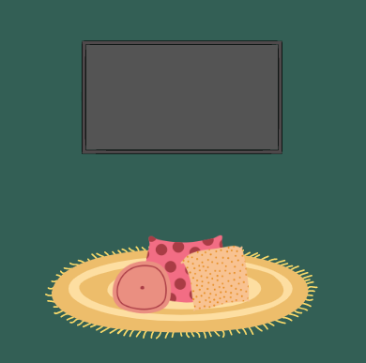

Sub-section: | Acropolis Remembrance
Exhibit number: | 5
Name of the exhibit: | Acropolis Virtual Museum
Type of exhibit: | Digital
Recommended preparation time: | 1 hour to 3 days
Required students: | 4
Brief description: | Experience the Acropolis hill with the help of the Acropolis Virtual Tour website
Materials and/or tools needed: | A projector, a laptop, the website of Acropolis Virtual Tour , a small table or stool, white paint (optional)
Dimensions of the exhibit:
Step by step construction instructions: | - Make sure the room you chose is light-proof  - If the walls are white, move to the next step. If not, paint them white color  - Place the projector and the laptop on the small table or stool  - Connect them together and display the website in the room  The room should look like this, with the projection being the Acropolis  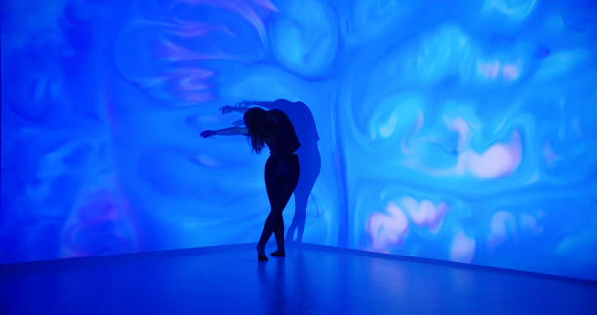

Sub-section: | Acropolis Remembrance
Exhibit number: | 2
Name of the exhibit: | Who Is It?
Type of exhibit: | Tangible
Recommended preparation time: | 2 hours
Required students: | 3
Brief description: | A stack of cards where each card will portray the ancient ruins and the famous people. Each student will have to pick one, without seeing it, and ask yes/no questions in order to find out his/her/their card
Materials and/or tools needed: | A printer, scissors, a small table
Dimensions of the exhibit: | The playing cards should be 64cm x 89cm in size and in total 20cm.
Step by step construction instructions: | - Decide on 10 ancient monuments and 10 famous ancient people to create cards for. (ex the Parthenon, The Temple of Nike, Socrates, Pericles etc)  - Cut them and place them -in stack and face down, on a small table.

